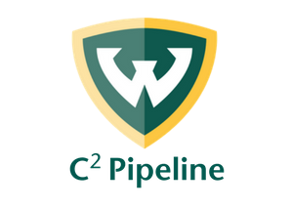
C2 Pipeline – Professional Development Plan for 2023-2024 Program Year
Employee:
Site:
Date:
------------------------------------------------------------------------------------------------------------------------------------------
According to the Licensing Rules for Child Care Centers, each staff member is required to complete 16 hours of professional development (annually) in any of the following areas:

- Child Development & Learning
- Health
- Safety & Nutrition
- Family & Community Collaboration
- Program Management
- Teaching & Learning
- Observation
- Documentation
- Assessment
- Integrations & Guidance
- Professionalism
- Child Care Center Administrative Rules

Site Coordinators should place notes in the “Comments” section about completion and implementation of trainings.
Needs to be Completed:
Course Name | Length | Date to Be Completed By: | Date Completed On: | Licensing Area Met

Completed:
Course Name | Date Completed | Length of Course (ex. 1.5 hours, 3.0 hours, 0.5 hours) | Location (ex. WSU, online, etc.) | Licensing Area Met | Site Coordinator Comments

