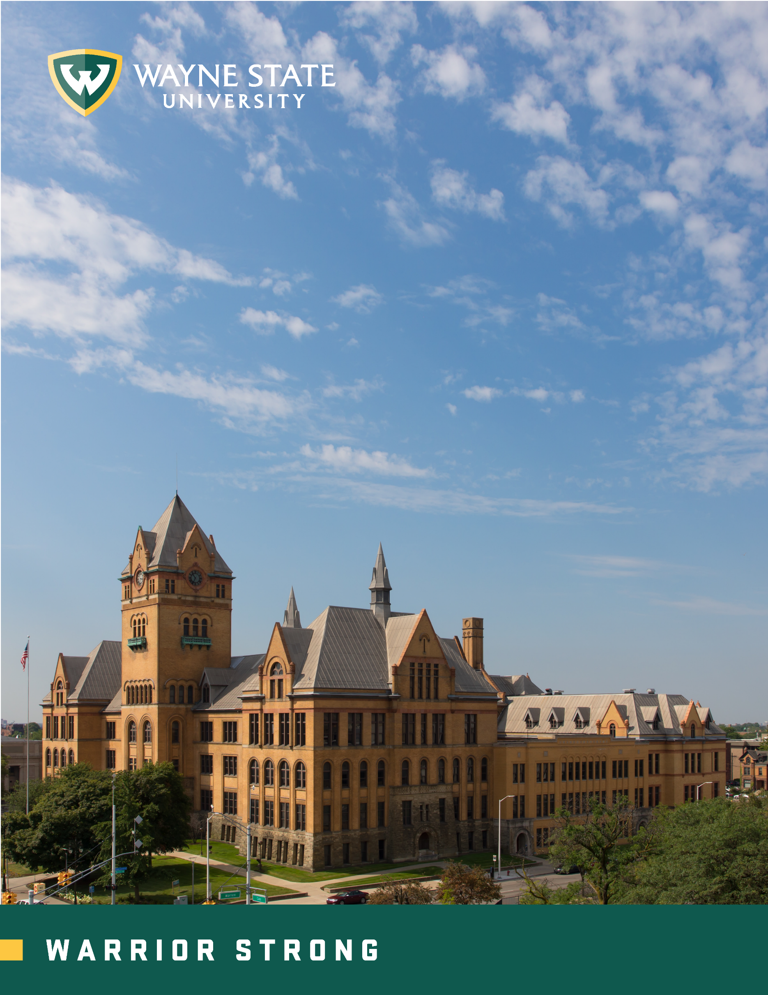
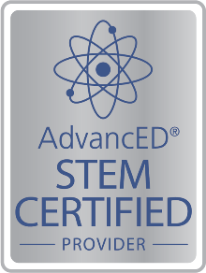
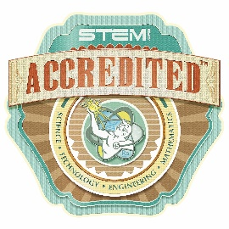
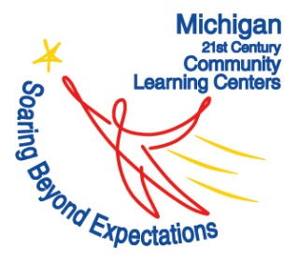
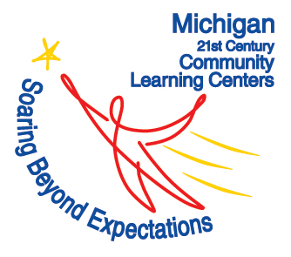
C² Pipeline
Student/Parent Handbook
2018 - 2019

Table of Contents

About Us: Our Mission …… .……………………………………………………………….……….… 3
Site Information ……………………………………………………………………………………...…. 4
Program Goals ...………………………………………………………………………………….….….5
About 21st Century Community Learning Centers ……………………………………………………...5
Policies and Procedures ……………………………………………………………………..............…...6 Registration …………………………………………………………………………………..….6
Attendance ………………………………………………………………………………….…...6
Incentive Program ……………………………………………………………………………….7
Dinner and Snacks ……………………………………………………………………….……...7
Field Trips ………………………………………………………………………………….……7
School Closure ……………………………………………………………………….………….7
Behavior …………………………………………………………………………………………8
Cell Phone Policy ………………………………………………………………………………..8
Social Media …………………………………………………………………………………………….8
Summer Program ……………………………………………………………………………..……........9
Partners .………...…………………………………………………………………………………….10
Wayne State Resources ………………………………………………………………………………11
Contact Information ……………………………………………………………………..……………. 12
Program Calendar ……………………………………..……………………………………………….13

About Us: Our Mission
WSU C² Pipeline is a college and career readiness program funded by the Michigan Department of Education through the 21st Century Community Learning Center grant. We operate within 19 Metro Detroit high schools. The afterschool program is free to all students enrolled at our high school sites. It is our mission to utilize hands-on, project-based learning to engage students with a wide variety of career interests. Participants will garner problem solving, critical thinking, leadership, and teamwork skills during general session; as well as receive academic assistance from our knowledgeable staff. Our enrichment block concentrates on STEM learning. STEM stands for Science, Technology, Engineering and Math. C² Pipeline enrichment curriculum is designed to have students to create, invent, experiment and push their boundaries in a safe, nurturing environment.
Afterschool programming operates for a total of 32 weeks during the academic school year. At each of our 19 centers, programming runs for two and a half hours daily, Monday through Thursday. During these two and a half hours, students are served dinner or a snack and have a chance to participate in a general session and enrichment. C² Pipeline also allows students the opportunity to receive assistance with homework, projects, and any school related work. Our enrichments cover topics that would not normally be covered during the school day in a fun and exciting, hands-on atmosphere, although not required students can earn digital badges for those enrichments where they complete the requirements.
Engineering/Technology | Health & Social Services | Business | Science
General Session SEL/Soft Skills For all Pathways
- Academic Skills  - Character  - College & Career Prep  - Communication | - Computer Literacy  - Customer Service  - Ethics  - Financial Literacy | - Higher Order Thinking  - Leadership  - Other  - Positive Self-Concept | - Self-Control & Self-Motivation  - Social Skills  - Team Building
Digital Badges
- 3D Printing & Design  - Alternative Transportation (Need for Speed)  - Audio Engineering  - Bio Tech Med (Biomedical Engineering)  - Rube Goldberg  - Computer Science, Code & Beyond  - Drones  - Electrical Engineering  - Explore It, Design It  - Fashion Engineering  - Green Architecture (earth Powered Engineering)  - Podcasts  - Audio Engineering  - Girls Who Code | - Anatomy in Clay  - Bio Tech Med (Biomedical Engineering)  - Forensic Science  - Empowerment Improv  - Human Genetic Variation  - STEM Sleuths  - STEM Debate  - STEPS  - Traumatic Brain Injury  - Your Blood, My Blood  - CPR / First Aid  - Tissue Engineering  - Science of Alcohol | - Entrepreneurship  - College & Finance  - Empowerment Improv  - Fashion Engineering  - Math Carnival  - Personal Finance Literacy  - SAT Prep  - Skills to Pay the Bills  - STEM Chess  - LinkedIn 101 | - Anatomy in Clay  - Basic Photography w/o Dark Room Access  - Bio Tech Med (Biomedical Engineering)  - Chemical Engineering  - Forensic Science  - Green Architecture (earth Powered Engineering)  - Human Genetic Variation  - STEM Busters / Myth Destroyers  - STEM Debate  - Bio-Technology  - Green Engineering  - Science of Alcohol  - Afterschool Universe
Site Information

The Wayne State University, College of Nursing, C² Pipeline program serves 9th-12th graders at 19 high schools throughout Macomb, Oakland and Wayne counties. Each center offers two and a half hours of afterschool programming that starts immediately after school is dismissed. The C² Pipeline program operates Monday - Thursday during the school year at each of our centers. To find out specific program times and enrichment offerings for a particular school, please review our website: www.c2pipeline.wayne.edu. If you have any additional questions, please feel free to email c2pipeline@wayne.edu.

C² Pipeline Campus Office C² Pipeline Lab

WSU College of Nursing Innovation & Curiosity Center
5557 Cass Ave. Room 334 5000 Gullen Mall Room 133
Detroit MI, 48202 Detroit MI, 48202

Site Locations

Center Line High School
26300 Arsenal St.
Center Line, MI 48015

Clintondale High School
35100 Little Mack Ave.
Clinton Township, MI 48035

Detroit Collegiate Prep
2200 W. Grand Blvd.
Detroit, MI 48202

Eastpointe High School
15501 Couzens Ave.
Eastpointe, MI 48201

Ecorse High School
27385 W. Outer Drive
Ecorse, MI 48229

Fitzgerald High School
23200 Ryan Rd.
Warren, MI 48091

Harper Woods High School
20225 Beaconsfield
Harper Woods, MI 48225
Lincoln High School
22900 Federal Ave.
Warren, MI 48089

Michigan Collegiate High School
31300 Ryan Rd.
Warren, MI 48092

Oak Park High School
13701 Oak Park Blvd.
Oak Park, MI 48237

Pontiac Academy for Excellence
196 Cesar E. Chavez Ave.
Pontiac, MI 48342

River Rouge High School
1460 W. Coolidge Hwy.
River Rouge, MI 48218

South Lake High School
21900 East Nine Mile Rd.
St. Clair Shores, MI 48080

Southfield Lathrup High School
19301 W. 12 Mile Rd.
Lathrup Village, MI 48076

Southfield Regional Academic Center
21705 Evergreen Rd.
Southfield, MI 48075

University High School
2521 Bermuda St.
Ferndale, MI 48220

Warren Mott High School
3131 12 Mile Rd.
Warren, MI 48092

Warren Woods Tower High School
27900 Bunert Rd.
Warren, MI 48088

Waterford Mott High School
1151 Scott Lake Rd.
Waterford Township, MI 48328

Afterschool Program Goals

- All participants become full time attendees of C² pipeline afterschool program by attending 30+ days of programming. Attendance days do not have to be consecutive.
- Full time attendees have improved study skills
- Full time attendees have higher homework completion rates
- Full time attendees have improved organizational and planning skills
- Full time attendees have higher GPAs
- Full time attendees will increase by half a letter grade in reading and math when possible
- Full time attendees will improve their scores on a standardized test, such as TABE
- Full time attendees have greater awareness of STEM and Health careers
- Full time attendees report feeling safe and supported in the program
- Increased communication/collaboration between teachers and school administration and C² Pipeline program
- Full time attendees apply for, are admitted to, and complete their first year of college or enter into a career related program
- More students will enter the workforce in a health career or pursue graduate school in a health-related field
- Students have confidence, skills, knowledge, attitudes and understanding to achieve success in life

About 21st Century Community Learning Centers (21st CCLC)
21st CCLC is a federally funded program dedicated to providing enriching academic opportunities during afterschool hours – primarily serving children in disadvantaged and underserved school districts. The aim of this program is to increase academic performance of participants in core areas, such as math and reading; as well as to provide educational services to the students’ families and communities. Check out these websites for more information:
- U.S. Department of Education: www2.ed.gov/programs/21stcclc/index.html
- Michigan Department of Education: www.michigan.gov/mde/0,4615,7-140-5236-39974--,00.html

Policies and Procedures

Registration
Students are required to register for C² Pipeline Afterschool program before attending. The application form is available on our website: www.c2pipeline.wayne.edu, or can be retrieved from the Site Coordinator in the school’s C² Pipeline office. Each weekday (Monday – Thursday) concentrates on a specific career pathway. Students may register for any or all pathways that interest them. The individual sites organize their own schedule based on student enrollment and participation.

Registration is open to all students attending the C² Pipeline school or to those students who are home schooled, participate in a virtual program or attend a parochial school as long as they are in that C² school’s catchment area. The program is designed to support students who come from disadvantaged backgrounds, either “Environmentally or Economically Disadvantaged”. C² Pipeline schools all meet the “Environmentally Disadvantaged” status and thus so do the students.

The following is a list of common characteristics that describe students who are Environmentally Disadvantaged. The examples are provided as guidance only, and are not intended to be all-inclusive:
- Person from high school with low average SAT/ACT scores or below the average state test results.
- Person from a school district where 50 percent or less of graduates go to college.
- Person who has a diagnosed physical or mental impairment that substantially limits participation in educational experiences.
- Person for whom English is not his or her primary language and for whom language is still a barrier to academic performance.
- Person who is first generation to attend college.
- Person from a high school where at least 30 percent of enrolled students are eligible for free or reduced price lunches.
Economically Disadvantaged: The following characteristics describe students who are considered Economically Disadvantaged:
- Students who come from a family with an annual income below a level based on low-income thresholds established by the U.S. Census Bureau, adjusted annually for changes in the Consumer Price Index.
- A family is a group of two or more individuals related by birth, marriage, or adoption who live together or an individual who is not living with any relatives.
Attendance
Attendance will be taken daily and is critical in order to earn and receive Digital Badge’s. Students must sign in at the beginning of each session to receive credit for that day. Attendance in the C² Pipeline Program is crucial to student success. Irregular and sporadic attendance will diminish a student’s ability to reap the full benefits of the program and gain the valuable experience that C² Pipeline offers.

An excused absence from day school will be counted as an excused absence from C² Pipeline. If a student attends day school but does not attend the afterschool program, a parent/guardian must call to excuse the absence. Site Coordinators and Assistant Site Coordinators will contact the student’s parents/guardians after the first unexcused absence. After the second absence, the student will be removed from the program and placed on an inactive list until the Site Coordinator and a parent/guardian have met to discuss a better course of action to ensure regular participation in the program. Student attendance in the program is reported to the Michigan Department of Education, as it is required to maintain compliance with our grant.

Student Incentive Program
By regularly participating in the after-school program, students have the opportunity to earn incentives. These awards will be allocated to students when they achieve attendance benchmarks. Attendance does not have to be consecutive to qualify for the incentive. For the 2018-19 school year, the incentives are earned at the following intervals after students complete an activity survey:
- 30 Days of Participation:
- 60 Days of Participation:
- 90 Days of Participation:

Dinner and Snacks
A nutritious meal will be provided to all enrolled students during the afterschool program. Each site has a 30-minute dinner block for students to eat and converse with peers. If your student has a serious food allergy, please notify the Site Coordinator so proper accommodations can be made.

Field Trips
C² Pipeline offers a variety of field trips and/or special events at little to no cost to students. Information regarding all off-campus excursions will be available to parents at least 1 week prior to the field trip. We encourage participation in off-site events as a reward to students and an opportunity for hands-on learning.

Transportation will be provided to all youth from the school to the destination and back to the school. Field trips may take place during regular afterschool program time, during the school day, early dismissal day or on weekends. Parent or guardian signature is mandatory on the permission slip before student can partake in the field trip. The Site Coordinator reserves the right to exclude any student who has displayed poor behavior on prior outings. Parents/guardians are encouraged to join our off-campus trips. Please contact the Site Coordinator to make arrangements.

School Closure
In the event of school closure – due to inclement weather, maintenance issues, holidays, etc. – the afterschool program will be cancelled for that day. The program will resume when the school reopens. Please review your school district calendar and check local radio and television stations for announcements of school cancellations.

Behavior Policy
In order to maintain a fun, safe and enriching environment – students are expect to treat peers, staff and volunteers with respect and kindness. Participants are learning skills that will be applied to their college and career experience and therefore are expected to act in a professional and appropriate manner.
Bullying and hazing are strictly prohibited and may result in dismissal from the program. Our main objective is higher learning and engagement for all high school students; however, Site Coordinators reserve the right to excuse students who habitually display destructive behavior which disturbs or interferes with efficient/effective programming. Students and parents will be notified prior to dismissal.

Students are expected to adhere to the same dress code as is outlined in the school district handbook. Attire that is considered inappropriate during the school day will also be deemed inappropriate during afterschool programming. Closed-toe shoes are recommended during after-school programming hours, as STEM enrichments may include potentially hazardous supplies.

Cell Phone Use
Cell phone use is not permitted during afterschool programming; staff reserves the right to collect electronic devices during the enrichment session – as it distracts from higher learning processes. Students are allowed to use cell phones at the end of the session, as they may need to communicate with guardians regarding transportation. Parents are welcome to call Site Coordinators during programming hours if they have concerns regarding their student. Participants have access to the afterschool program phone, and are welcome to use it when warranted.

Social Media
WSU C² Pipeline uses social media to communicate program news and events with students, families, partners and the community. Parents are encouraged to follow us on Facebook, Instagram and Twitter to stay informed about opportunities for their student, as well as get involved in our program activities. It is an excellent tool to share reminders about scholarships, state testing and federal financial aid. We also welcome social media as a platform to communicate with you about any questions, concerns or advice you may have regarding our program.

The links to our social media accounts are as follows:
- Facebook: www.facebook.com/WSUC2Pipeline/
- Instagram: www.instagram.com/wsuc2pipeline/
- Twitter: www.twitter.com/wsuc2pipeline

Summer Program
C2 Pipeline offers several different opportunities for summer learning on Wayne State University campus. Camps are available to all rising 9th-12th graders. The programs are free for students who are enrolled in the C² Pipeline afterschool program.

Our Summer Day Camp program runs from Monday – Thursday. Each of the camps offered concentrate on a different enrichment. Students are encouraged to enroll in more than one of the day camps if they have many career interests. Transportation and lunch is provided daily for each camp.

The Warrior College Experience is our residential camp. Students will live on campus for 11 days. During this time, they will attend lectures with Wayne State professors, gain hands-on experience in our labs, and compete for scholarships and dual enrollment opportunities. Please refer to our website for more information regarding our summer programming: www.c2pipeline.wayne.edu/summer

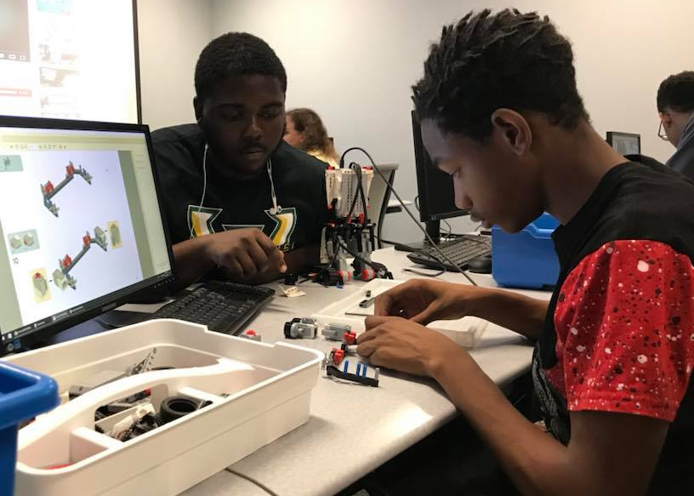
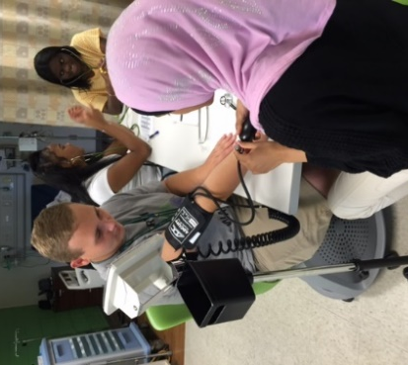

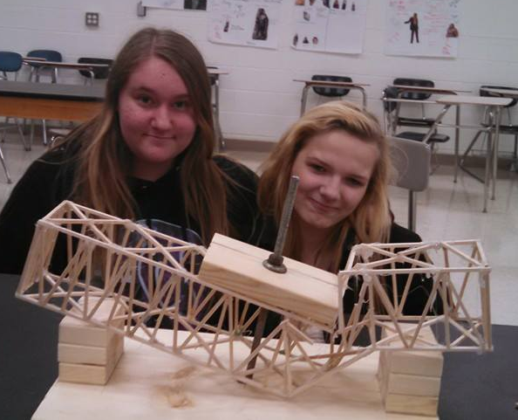
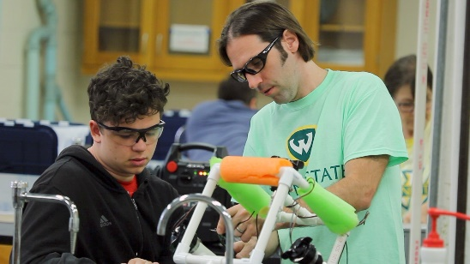
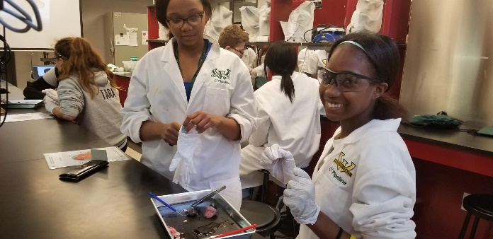

Our Partners

WSU College of Nursing
5557 Cass. Ave
Detroit, MI 48202
313-577-4082
nursinginfo@wayne.edu

WSU School of Medicine
320 E. Canfield Ave.
Detroit, MI 48201
313-577-1450
mdadmissions@wayne.edu

WSU School of Social Work
5447 Woodward Avenue
Detroit MI, 48202
313-577-4409

WSU College of Education
Kinesiology, Health & Sport Studies
441 Education Bldg.
Detroit, MI 48202
313-577-1620
AskCOE@wayne.edu
WSU Mike Illitch School of Business
2771 Woodward Avenue
Detroit, Michigan 48201
313-5677-4501

WSU Eugene Applebaum
College of Pharmacy and Health Sciences
259 Mack Avenue
Detroit, MI 48201
313-577-1716
cphsinfo@wayne.edu

WSU College of Engineering
313-577-3780
5050 Anthony Wayne Dr.
Detroit, MI 48202
ehd@wayne.edu

U of D Mercy School of Dentistry
2700 Martin Luther King, Jr. Blvd
Detroit, MI 48208
313-494-6611
dental@udmercy.edu
Wayne State Partners & Resources

Admissions Department
Important Dates
Wayne State Application Deadlines:
- Fall Semester: Aug. 1
- Winter Semester: Dec. 1
- Spring/Summer Semester: April 1
FAFSA Deadline: March 1
Wayne State Open House: October 13
Winter Recess: December 24 – January 1
Michigan Merit Exam:
- SAT with Essay: April 9
- PSAT 8/9/10: April 9
- ACT Work Keys: April 10
Day Camp Begins: June 17
Warriors College Experience Application Deadline: July 1

www.wayne.edu/admissions
313-577-2100
admissions@wayne.edu
42 W. Warren
Detroit, MI 48201

University Advising Center
www.wayne.edu/advising/center/
313-577-2680
univadvising@wayne.edu
premedadvising@wayne.edu
1600 David Adamany Undergraduate Library

Office of Student Financial Aid
www.wayne.edu/financial-aid/
313-577-2100
studentservice@wayne.edu
42 W. Warren Avenue
Detroit, MI 48202

Office of the Registrar
www.reg.wayne.edu/
313-577-3541
registration@wayne.edu
42 W. Warren
Detroit, MI 48201

Irvin D. Reid Honors College
https://honors.wayne.edu/
(313) 577-3030
honors@wayne.edu
2100 Undergraduate Library
5155 Gullen Mall
Detroit, MI 48202

Program Contact Information
C² Pipeline Administrative Office
E: c2pipeline@wayne.edu P: (313) 577-1847

Donald Neal
Project Director/PI
en6396@wayne.edu
(313) 577- 8605

Maria Ventimiglia
Student Engagement Coordinator
eb1162@wayne.edu
(313) 577-9006

Jacquie Kulcsar
Site Coordinator
Ecorse High School
fo1564@wayne.edu
(734) 626-5769

Sonja Beasley-Hall
Site Coordinator
Harper Woods High School
sonja.beasley-hall@wayne.edu
(313) 506-3150

Carla Carlton
Site Coordinator
Waterford Mott High School
carlacarlton@wayne.edu
(586) 909-1848

Letrell Henley
Site Coordinator
Michigan Collegiate
letrell.henley@wayne.edu
(586) 777-5792 Ext. 338

Geoffrey Jones
Site Coordinator
Fitzgerald High School
bt3545@wayne.edu
(213) 631-0502

Matthew Hokanson
Site Coordinator
Southfield Arts & Technology
matthew.hokanson@wayne.edu
(248) 202-8669

Tansi Leake
Assistant Project Director
tansi.leake@wayne.edu
(313) 577-4602

DeJanae Douglas
Site Coordinator
University High School
dejanaedenice@wayne.edu
(248) 635-5442

Pamela Geeck
Site Coordinator
Oak Park High School
pamela.geeck@wayne.edu
(248) 563-2401

Gene Hall
Site Coordinator
Detroit Collegiate Prep
gene.hall@wayne.edu
(313) 506-3051

Jeffrey Jantz
Site Coordinator
South Lake High School
ei1839@wayne.edu
(586) 435-1069 Ext. 2459

Genea Ewing
Site Coordinator
Warren Mott High School
genea.ewing@wayne.edu
(586) 574-3250

Cheryl Rhoades
Site Coordinator
Eastpointe High School
cheryl.rhoades@wayne.edu
(586) 260-5841

Rhonda Holstein
Site Coordinator
Southfield Regional
rhonda.holstein@wayne.edu
(248) 238-0801

Sandra Friedli
STEM/Replicator Lab Manager
aj0818@wayne.edu
(313) 577-3499

Peter Durham
Site Coordinator
Pontiac Academy for Excellence
peter.durham@wayne.edu
(248) 390-4847

Clinton Loh
Site Coordinator
Clintondale High School
clinton.loh@wayne.edu
(248) 346-2485

Samantha Wolfe
Site Coordinator
Center Line High School
samantha.wolfe@wayne.edu
(248) 842-6959

Lekita Jones
Site Coordinator
Warren Woods Towers
ab9680@wayne.edu
(313) 587-9250

Stephen Balint
Site Coordinator
River Rouge High School
ec1427@wayne.edu
(313) 297-9600

Shawna Rembold
Site Coordinator
Lincoln High School
shawnarembold@wayne.edu
(248) 688-8087

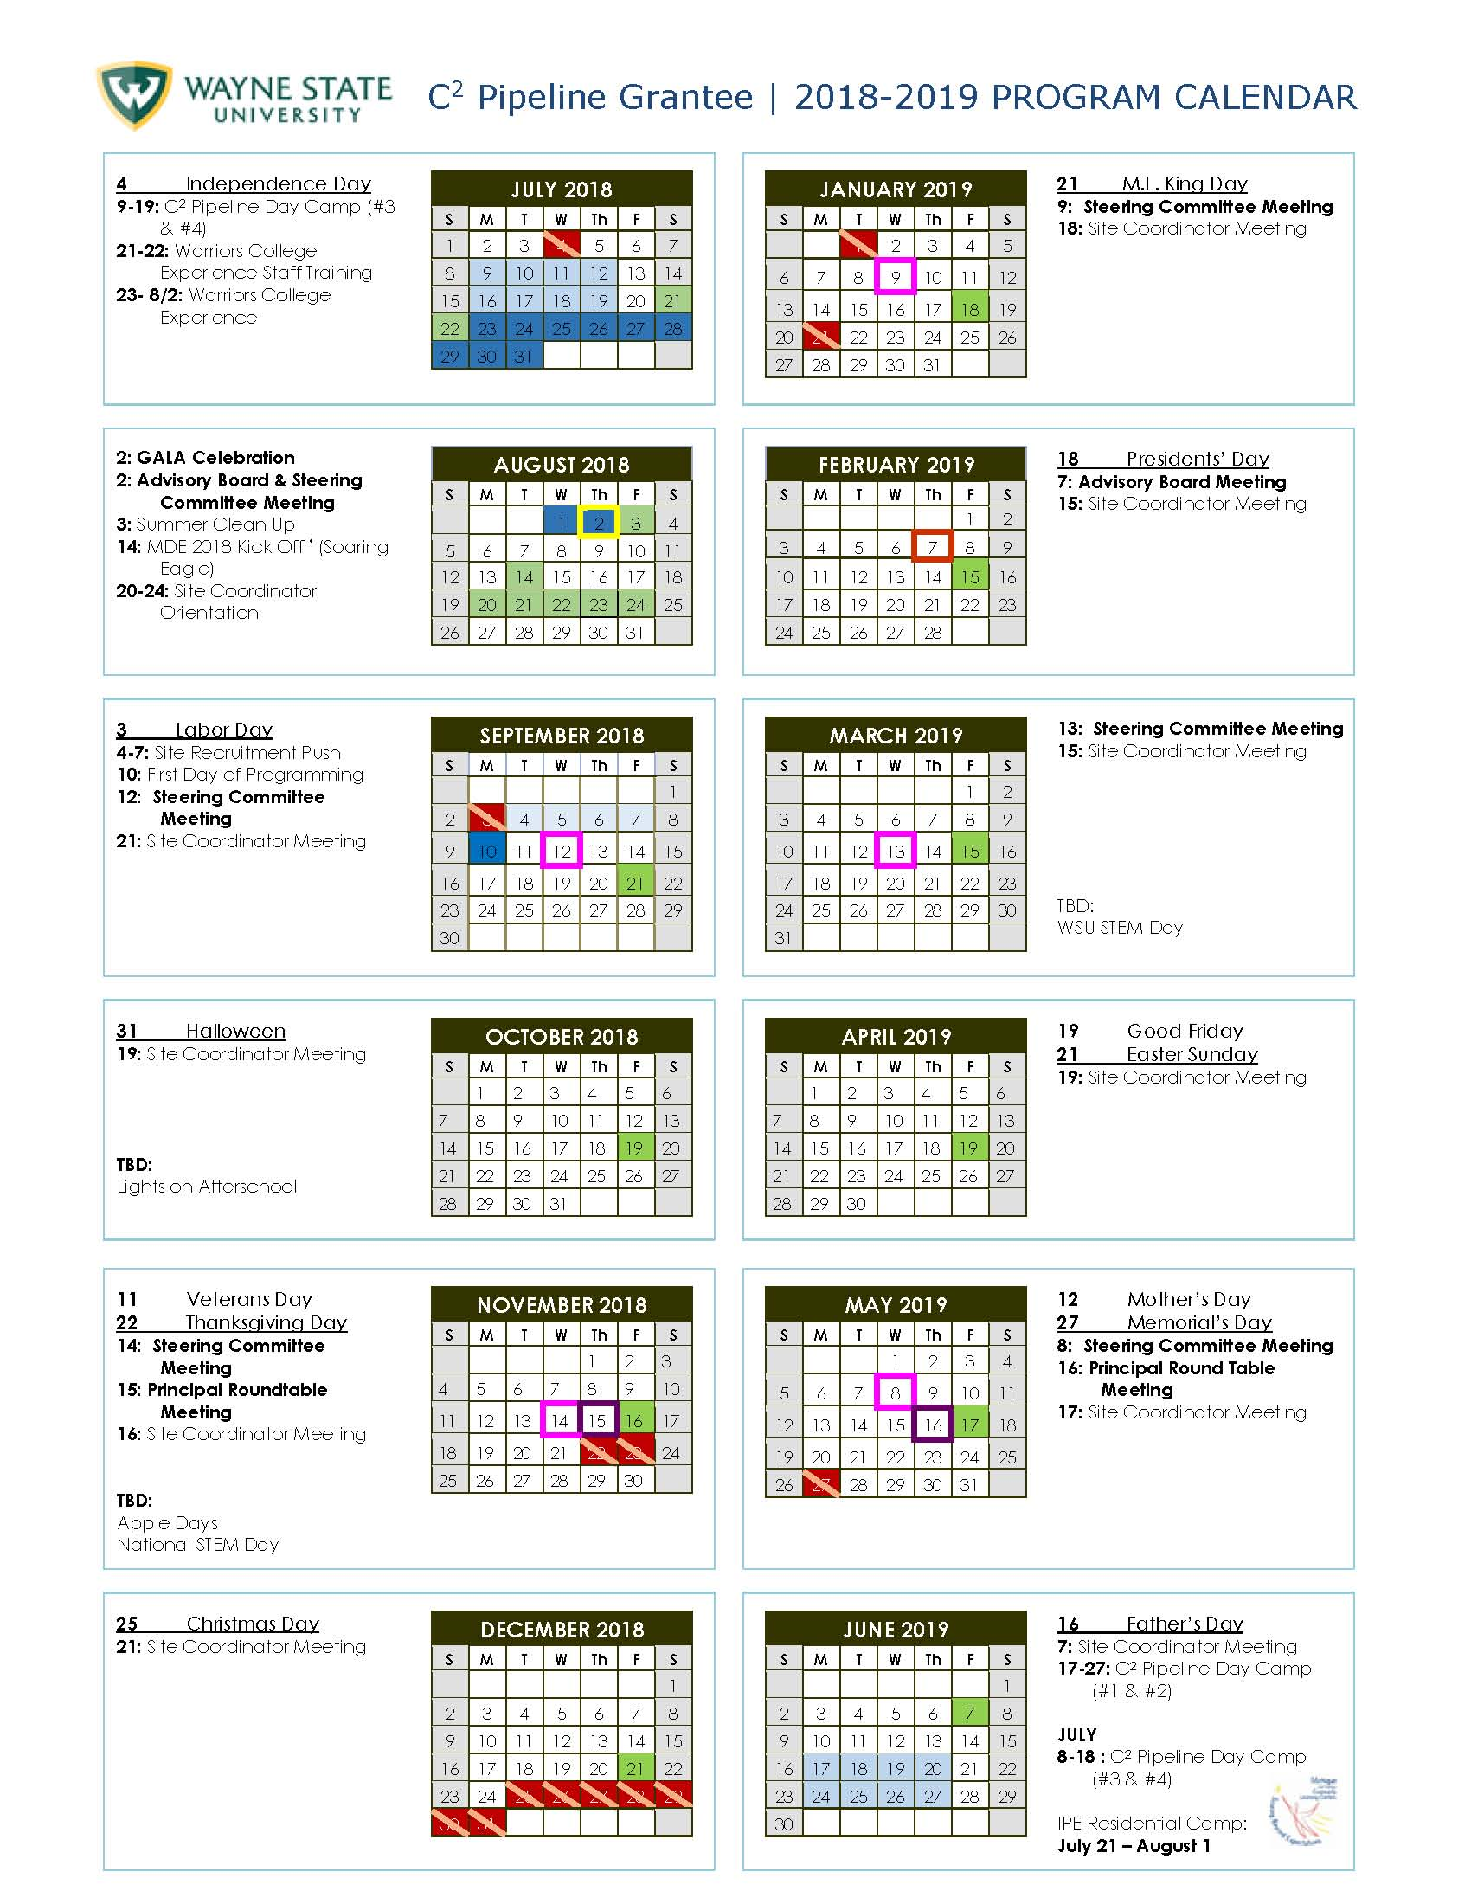

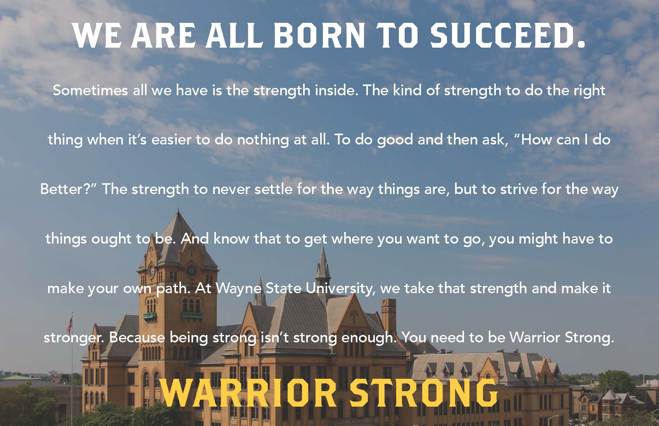

C² Pipeline is a Wayne State University, College of Nursing program that is
AdvanceEd STEM Certified and STEM.Org STEM Accredited.

It is funded by a 21st Century Community Learning Centers (CCLC) Grant through the
Michigan Department of Education

