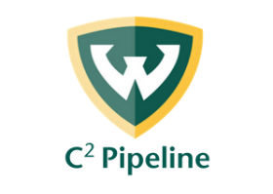
C2 Pipeline Mission, Vision and Program Pillars

Mission
C² Pipeline in the Wayne State University College of Nursing inspires students to prepare for college/career success through immersive explorations of career pathways, including STEM fields, that give them the skills and knowledge they need to engage in real-life reasoning, problem solving, planning and collaboration.

Vision
C² Pipeline in the Wayne State University College of Nursing is a pre-college university model to guide high school students to graduate with a plan for the future and the skills, confidence, knowledge, and attitude necessary to positively impact their lives and the lives of others.

Program Pillars
- STUDENTS: Offer quality programming, a safe space, and advocate for their success.
- STAKEHOLDERS: Collaboration between parents, community members, school personnel, partners, Wayne State University, volunteers, and program staff to ensure positive student outcomes.
- PROGRAM ACTIVITIES: Will align to Common Core, Next Generation Science Standards, Michigan Specific Content Expectations, or organizational standards, based on best-practices and demonstrated effectiveness.
- FUNDING: Leverage resources to support and sustain the C2 Pipeline program.

M.Wilmot 7/24/2023

