How to Submit a Timesheet (for Salaried Staff)
Complete these steps after using PTO so that your time off is accurately reflected.
- On the Academica home screen, click on “Time Sheet” (located either under “My Frequent Links” or under “Resources” -> “Employee Resources” -> “Employee Self-Service”).
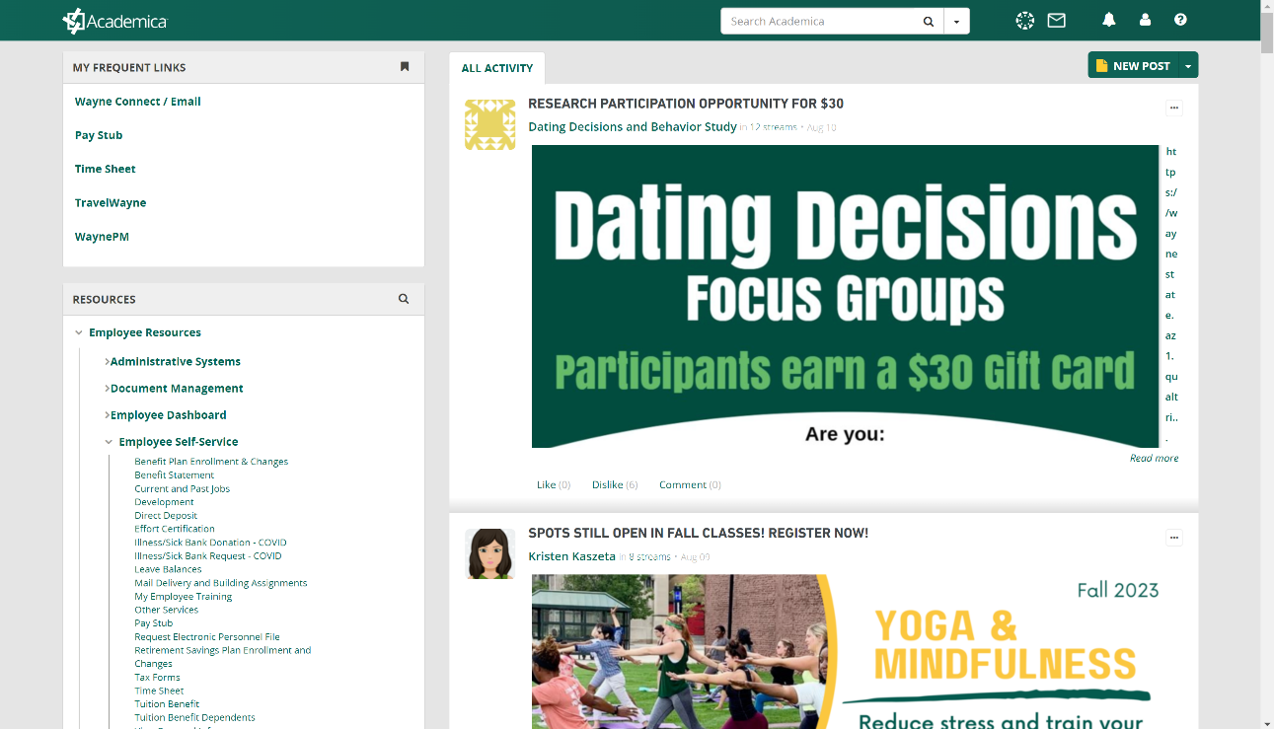
- Select the pay period you’re entering time in from the drop-down menu next to your job title.
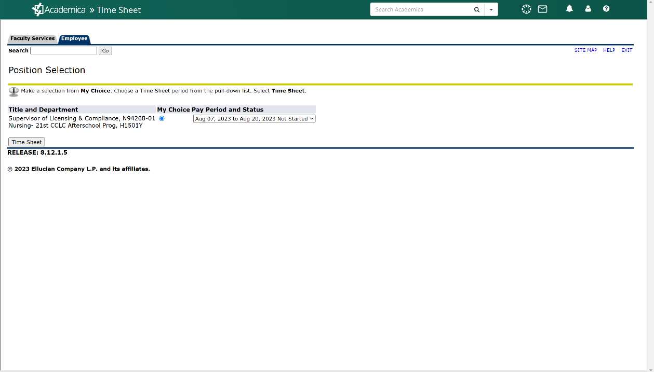

- For your time to be accurately reflected, you’ll need to click “Enter Hours” on the correct column for each date you took PTO on. Remember, a full day is 7.5 hours (your 1.0 hour lunch is in addition to that). For example, if you took a full day of vacation on August 7th, you’d click “Enter Hours” under August 7th on the “Vacation” row, then manually enter in 7.5 in the “Hours” box, then click the “Save” button.
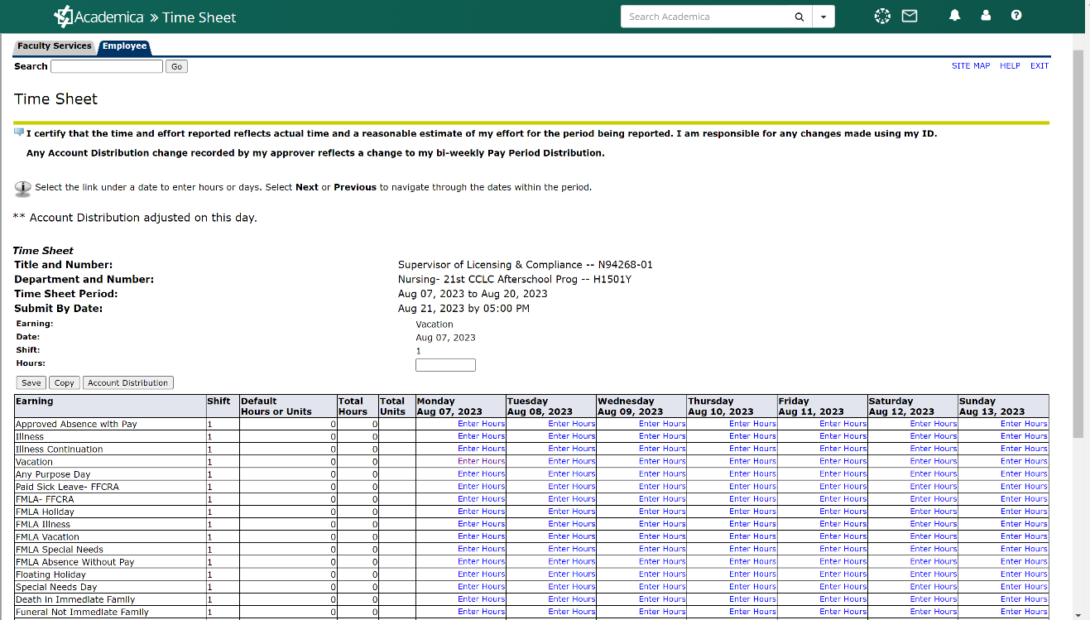
- After you’ve entered in your PTO for the pay period (there are two weeks per pay period, so make sure to click “Next” at the bottom of the page to get to the second week), you’ll scroll to the bottom of the page and click “Submit for Approval.” Your timesheet isn’t complete until you submit it for approval!
