How to Request PTO on MyCON
Complete these steps in order for your PTO request to be submitted and processed. Remember your PTO request isn’t approved until you receive an email from your supervisor.
- Navigate to https://nursing.wayne.edu/
- Scroll down to the bottom of the page and click “MyCON Login”
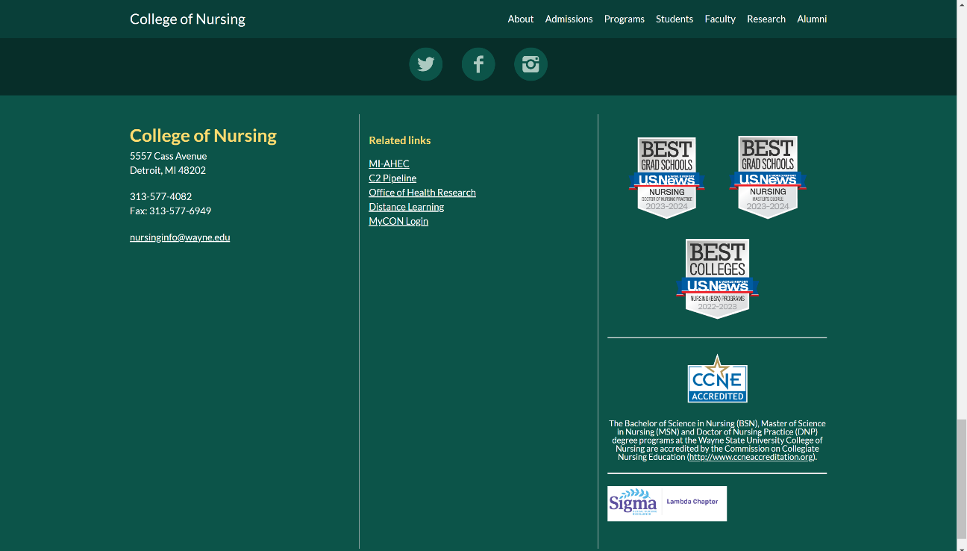
- Enter your AccessID and password and select “Faculty & Staff Portal.” Then click “Login”
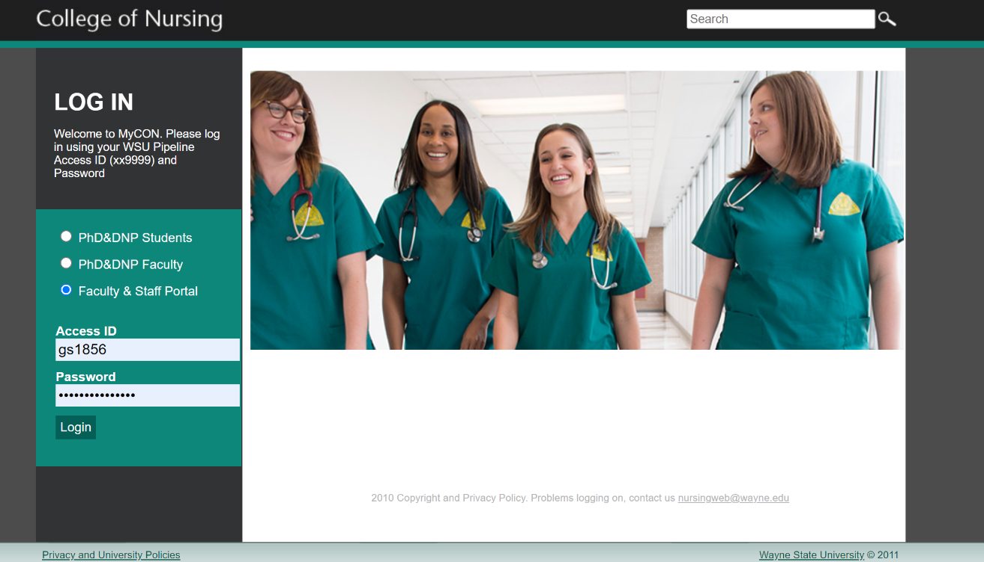
- Click “Time Off” to navigate to the request form.
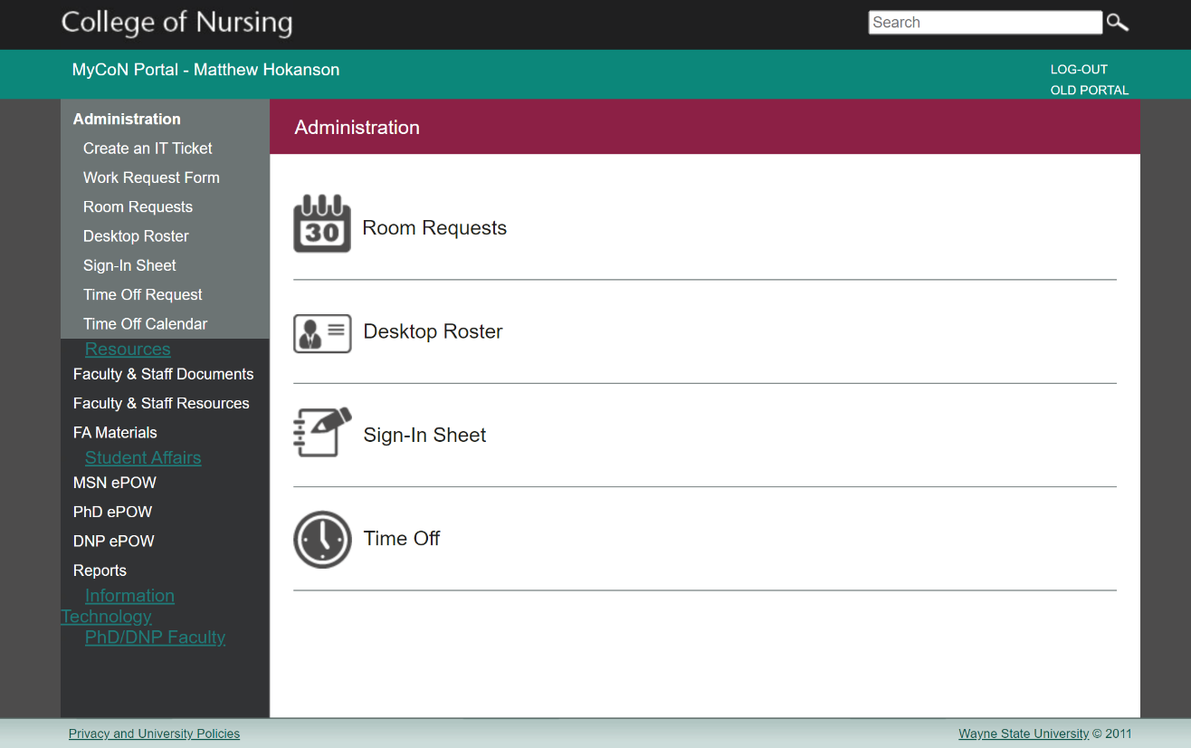

- Enter: 1) The reason you’re requesting PTO (vacation, illness, any purpose, funeral, etc.); 2) The date your PTO begins; 3) The date you’ll be returning to work; 4) The total number of hours (7.5= a full workday); and 5) A note regarding how it will impact your site programming schedule. Then click “Request Time Off”
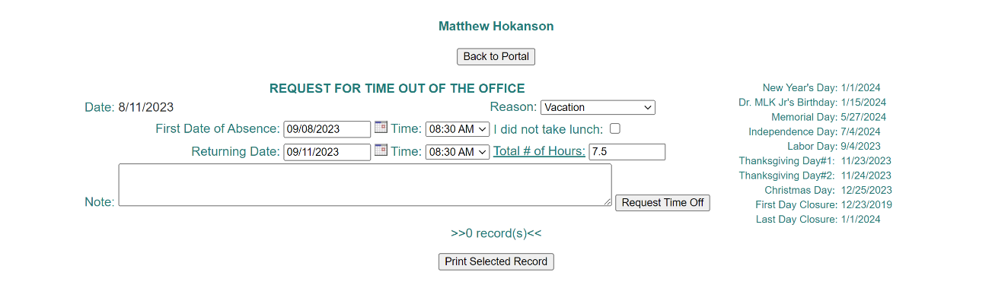

- You’ll receive an email confirmation of your PTO request. Your supervisor will review your request and you’ll receive a second email confirmation with the status of your PTO request.
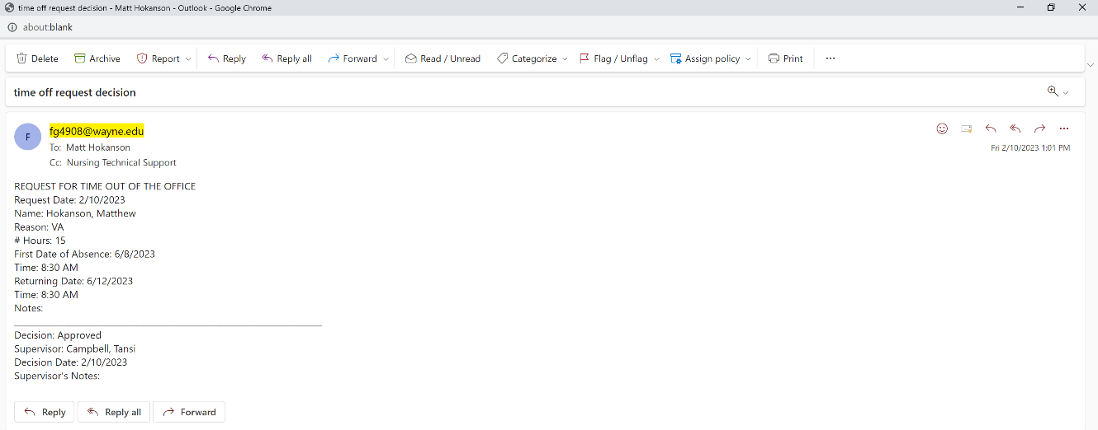

- If something changes and you need to edit/cancel your request, login to MyCON and make the necessary changes.

