WSU C2 Pipeline PY 2023/2024 Field Trip Process and Information

Transportation Vendor WSU preferred:

Lora Showalter
Sales/Office Manager
National Trails
O: 248-353-9510 ext. 101
C: 313-854-1816
24 hour emergency dispatch 248-514-9345
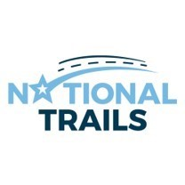
Cohort L-1 Index 370926=TBD
Cohort L-2 Index 370927=TBD
Cohort L-3 Index 370928=TBD

Link to schedule a field trip: https://forms.wayne.edu/5b748ec22086f/

NOTE! Until you receive a confirmation email from Tansi Campbell, field trips are NOT approved. Field trip requests that are not submitted at least 4 weeks prior to the field trip date will automatically be denied.

